**13. SET THEORY**

**Solution Exercise – Easy**

1. (b) :

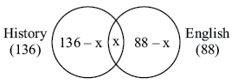

(136 − *x*) + (88 − *x*) + *x* = 200

*x* = 24

2. (c) :

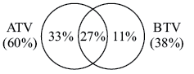

Watched neither ATV or BTV = 100 − (33 + 27 + 11) = 29%

3. (a) :

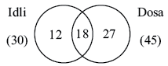

Total number of people = (12 + 18 + 27) + 24 = 81

4. (b) :

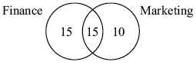

Students attending both classes = 80 − (15 + 15 + 10) = 40

5. (d) :

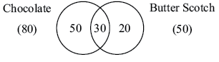

Total number of people = 50 + 30 + 20 = 100

***Solutions for questions* *6 to 11:***

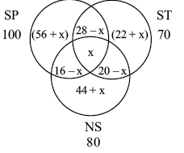

None = 10

Those who like atleast 1 = 200 − 10 = 190.

(56 + *x*) + (22 + *x*) + (44 + *x*) + (28 − *x*) + (16 − *x*) + (20 − *x*) + *x* = 190

*x* = 4

6. (b)

7. (c) : 16 − 4 = 12

8. (a) : 80 + (28 − 4) + (22 + 4) = 130

9. (d) : 56 + 4 + 28 − 4 + 22 + 4 = 110

10. (c) : 56 + 4 + 22 + 4 + 44 + 4 = 134

11. (a) : 28 − 4 + 16 − 4 + 20 − 4 + 4 = 56

12. (d) : Not known anything = 2000 − [340 + 170 + 350 + 210 + 260 + 400 + 156]

= 2000 − 1986

= 14

Ratio = 

***Solutions for questions* *13 to 16:***

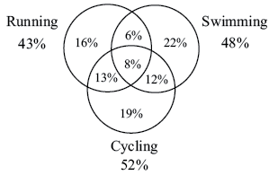

None = 100% − [52% + 16% + 6% + 22%] = 4%

13. (b) : 16% of 500 = 80

14. (b) : Ratio = 

15. (c) : Ratio = 

16. (c) : 13 + 12 + 6 + 8 = 39%

39% of 500 = 195

17. (c) :

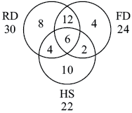

Now = 50 − [30 + 10 + 2 + 4] = 4

***Solutions for questions* *18 to 21:***

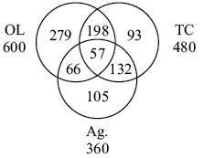

18. (d) : 600 + 93 + 132 + 105 = 930

19. (d) : 279 + 93 + 105 = 477

20. (c) : 66 + 132 + 198 + 57 = 453

21. (c) : 930 − 57 = 873

***Solutions for questions 22 and 23:***

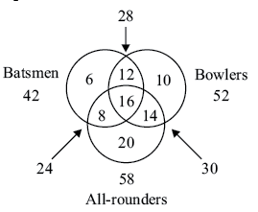

22. (a) : 42 + 20 + 14 + 10 = 86

23. (a)

***Solutions for questions* *24 and 25:***

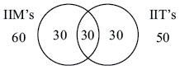

24. (d) : Students in group = 30 + 30 + *x* = 80

25. (b)

26. (b) :

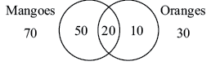

Atleast one fruit = 50 + 20 + 10 = 80

27. (c) :

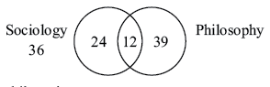

Only Philosophy = 75 − 36

| Sociology & Philosophy − Only Philosophy |

| 12 − 39| = 27

28. (b) :

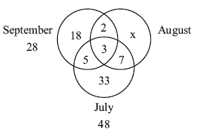

So, number of people reading the newspaper in consecutive months *i.e*. July and August and August and September is 2 + 7 = 9

(We can find the value is '*x*' *i.e*. only August, but we don't need it).

***Solutions for questions 29 to 31:***

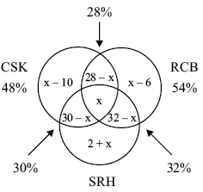

None = 6%

94 = *x* − 10 + *x* − 6 + *x* + 2 + 28 − *x* + 30 − *x* + 32 − *x* + *x*

*x* = 18%

29. (d) : 

30. (b) : 30 − *x* = 12%

*i.e*. 12% of 2000

= 240

31. (c) : Percentage

= 

(Without solving, we can see that it's less than 10% & more than 5%).

***Solutions for questions 32 and 33:***

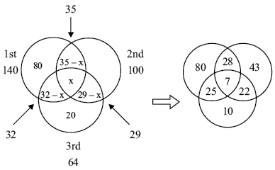

Let those who participated all 3 days be '*x*'.

Then, 80 + 35 − *x* + 32 − *x* + *x* = 140

147 − *x* = 140

*x* = 7

32. (d)

33. (b) : Total participants,

140 + (100 − 35 − 22) + (64 − 32 − 22)

= 140 + 43 + 10

= 193

Only one day = 80 + 43 + 10 = 133

∴ Percentage of participants who intended only one day

= 

34. (a) :

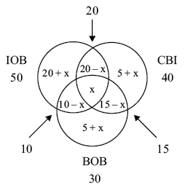

None = 20

Let these who followed all three = *x*

Now, 50 + 5 + *x* + 15 − *x* + 5 − *x* + 200 = 100

95 + *x* = 100

⇒ *x* = 5

35. (d) :

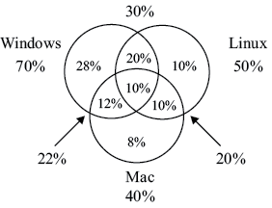

More than 1 = 52% (20% + 10% + 12% + 10%)

36. (d) :

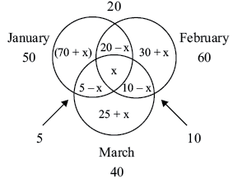

None = 5

Total number of houses = 125

⇒ 125 = 50 + 30 + *x* + 25 + *x* + 10 − *x* + 5

⇒ *x* = 5

***Solutions for questions 37 to 40:***

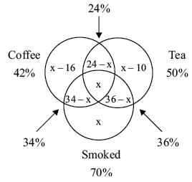

None = 8%

Now, we have

42 + *x* − 10 + 36 − *x* + *x* + 8 = 100

76 + *x* = 100

*x* = 24%

37. (b) : = 

38. (d) : *x* − 16 + 34 − *x* + *x*

= *x* + 18

= 24 + 18

= 42

*i.e*. 42% of 3000

= 1260 students

39. (c) : Coffee & Tea but not smoking = 24 − *x*

= 24 − 24

= 0%

Number of students = 0

∴ Percentage among those who like atleast one will also be '0'.

40. (c) : 

= 

***Solutions for questions 41 to 44:***

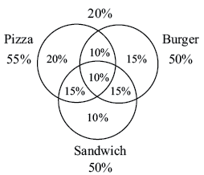

None = 5%

41. (a) :  i.e. 100 % more

42. (c) : 15%

43. (b) : Atleast two = 10% + 15% + 15% + 10% = 50%

44. (d) : 10% of 180 = 18

45. (a) : Let the people who watch all three be *x*.

46. (a) : Number 30 lies on the portion common to the figures representing families having TV and Scooters only.

47. (b) : *T* represents the artists who are both story-writers and singers but not dancers.

48. (b) : Circle *A* (Physics)

The region marked *p* represent for Physics.

Circle *B* (Chemistry)

Circle *C* (Mathematics)

So, the region marked *u* represent for Physics and Mathematics but not Chemistry.

Therefore, (b) is the right answer.

49. (c) : Suppose *x*% families own a phone and a car.

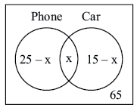

(25 − *x*) + *x* + (15 − *x*) + 65 = 100

∴ 5% families own a phone and a car.

Car or Phone families % = (25 − 5) + 5 + (15 − 5) = 35

Total families lived in town = 

Hence, statement (II) and (III) are correct.

50. (b) : Total number of students to be appeared in Examination = 500

Number of students who failed in atleast two subjects = 10 + 12 + 12 + 5 = 39

As, 39 students have failed out of total 500 students.

So, the percentage will be = 

**Solution Exercise – Medium**

***Solutions for questions 1 to 3:***

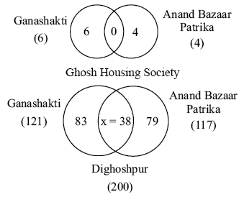

Let '*x*' be the number of people who read both in Dighoshpur.

Then, 121 − *x + x* + 117 − *x* = 200

238 − *x* = 200

⇒ *x* = 38

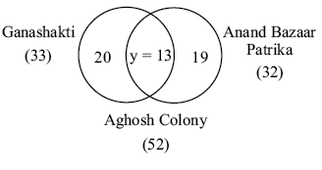

Let '*y*' be the number of people in Aghosh Colony who read both.

Then, 33 − *y + y* + 32 − *y* = 52

⇒ *y* = 23

1. (b) : Number of persons in Dighoshpur who read only Ganashakti = 83.

2. (a) : Number of persons in Aghosh Colony who read both the newspapers = 13.

3. (c) : Number of persons in Aghosh colony who read only 1 newspaper = 20 + 19 = 39.

4. (c) :

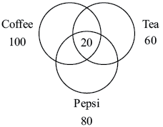

*n*(Coffee) + *n*(Tea) + *n*(Pepsi) = *n*(only 1) + 2*n*(only 2) + 3*n*( all 3).

100 + 60 + 80 = *n*(only 1) + 2(60 − 20) + 3(20)

240 = *n*(only 1) + 80 + 60

*n*(only) = 100

*n*(Total) = *n*(only 1) + *n*(only 2) + *n*(all 3) + *n*(none)

200 = 100 + 40 + 20 + *n*(none)

*n*(none) = 40

5. (d) : 3 digit numbers: 100, 101, ...... , 999.

Multiples of 6 = 

= 166 − 17 + 1 = 150

Multiples of 5 (even numbers) check with 10.

= 

= 99 − 10 + 1 = 90

Multiples of 3 = 

= 333 − 34 + 1 = 300.

*A*  *B* *i.e*. 6 & 5 multiples are,

= 

= 30

*B*  *C* *i.e*. 5 even and 3 *i.e*. again we will check with 30.

∴ Multiples = 30

*A*  *C* *i.e*. 6 and 3

∴ Multiples = 150

*A*  *B*  *C i.e*. 6, 5 even, 3

∴ Multiples = 30

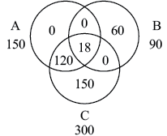

*A*  *B*  *C* = 300 + 60 = 360

6. (c) :

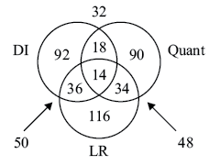

|  |  |  |
| --- | --- | --- |
|  | Pass | Fail |
| Quant | 156 | 44 |
| DI | 160 | 40 |
| LR | 200 | 0 |

Since all have passed in LR, there would be no student who fail in all subjects.

***Solutions for questions 7 to 9:***

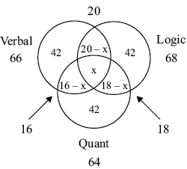

*n*(Verbal) + *n*(Logic) + *n*(Quant) = *n*(only 1) + 2*n*(only 2) + 3*n*(only 3)

66 + 68 + 64 = 42 × 3 + 2 (20 − *n* + 16 − *n* + 18 − *n*) + 3*n*

196 = 234 − 3*n*

*n* = 12

7. (a) : 3 × 42 = 126

8. (c) : *x* = 12

9. (b) : = 

***Solutions for questions 10 and 11:***

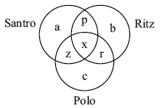

Total number of persons who owned cars = 120 – 5 = 115

Owned only one car = a + b + c = 30

Owned only two cars = p + q + r = 55

10. (b) : Owned all three cars

= Total owned – [Owned one car + Owned two cars]

= 115 – [30 + 55] = 30

11. (a) : Owned in atleast two

= Owned two + Owned three

= 55 + 30 = 85

***Solutions for questions 12 to 15:***

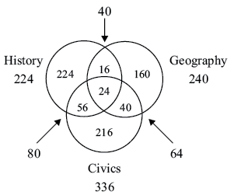

12. (d) : Total participants who chose atleast one area

= 128 + 160 + 216 + 16 + 40 + 56 + 24 = 640

Hence, 

∴ Participants who did not choose any = 880 − 640 = 240

13. (d) : Number who chose only one = 128 + 160 + 216 = 504

So, 

14. (c) : Atleast two = 56 + 16 + 40 + 24 = 136

15. (b) : Ratio = 

***Solutions for questions 16 and 17:***

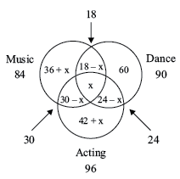

For Dance, 60 + 18 − *x* + 24 − *x* + *x* = 90

*x* = 102 − 90 = 12

16. (c) : Number of students in school

= 96 + 36 + *x* + 18 − *x* + 60

= 96 + 36 + 18 + 60

= 210

17. (c) : 30 − *x*

= 30 − 12

= 18

***Solutions for questions 18 to 21:***

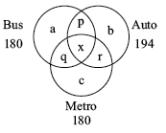

 ..... (1)

 ..... (2)

*b* = *a* + 28 ..... (3)

*c* = *a* + 24 ..... (4)

*n*(Bus) + *n*(Auto) + *n*(Metor) = *a + b + c* + 2(*p + q + r*) + 3*x*

186 + 194 + 180 = 560 = *a + b + c* + 2(*p + q + r*) + 3*x*

Also 340 = *a + b + c* + *p + q + r* + *x*

220 = *p + q + r* + 2*x*

220 = *p + q + r* + *x* + *x*

220 = *x + x* (from (1))

440 = 11*x*

*x* = 40

18. (c)

19. (c) : *p + q + r + x* = 

= 

20. (c) : *p + q + r* = 180 − 40 = 140

21. (d) : Since we cannot find the individual values of *p, q, r*. Hence, data is insufficient.

22. (c) :

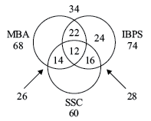

Only IBPS = 24

***Solutions for questions 23 to 25:***

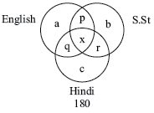

None = 21

*a + b + c* = 388 , *p + q + r* = 63

Total = *a + b + c + p + q + r + x* + none

540 = 388 + 63 + *x* + 21

*x* = 68

23. (b)

24. (b) : Atleast two = *p + q + r + x*

= 63 + 68 = 131

25. (d) : Pass in one and two subjects = *a + b + c + p + q + r*

= 388 + 63 = 451

26. (c) :

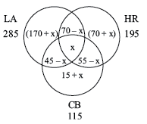

Let '*x*' be individuals who like all 3.

Those who like atleast 1 = 520 −50 = 450

(170 + *x*) + (70 + *x*) + (15 + *x*) + (70 − *x*) + (45 − *x*) + (55 − *x*) + *x* = 450

⇒ *x* = 25

27. (c) : = (170 + *x*) + (70 + *x*) + (15 + *x*) = 330

28. (d) :

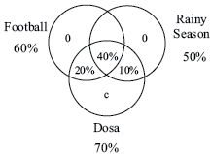

As we have to minimize only Football.

We put the entire 60% in the area of intersection.

29. (c) :

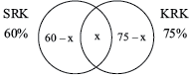

60 − *x + x* + 75 − *x* = 100

135 − *x* = 100

*x* = 35% *i.e*. the minimum that could like both, than this would make the total number more than 100%.

30. (b) :

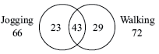

Number of people who liked both jogging and walking.

= 72 + 66 – 95 = 43

Hence,

Minimum 43 can like both

& Maximum 66 can like both.

***Solutions for questions 31 to 33:***

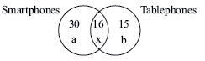

We have,

*a + b + x* = 50 ..... (1)

*b = a* − 4 ..... (2)

⇒ *a* − *b* = 4

2*a + x* = 54 (Putting (2) in (1)) ..... (3)

Also, *a = x* + 3

⇒ *a − x* = 3 ..... (4)

3*a* = 57 (Putting (4) in (3))

⇒ *a* = 19

⇒ *b* = 19 − 4 = 15

⇒ *x* = 19 − 3 = 16

31. (c)

32. (b) : Percentage = 

33. (b) : Increased by 20%

∴ 20% of *b*

20% of 15 = 3

34. (a) :

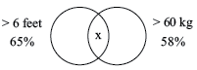

65% + 58% − *x* = 100%

*x* = 23%

***Solutions for questions 35 and 36:***

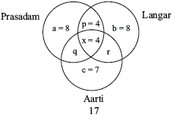

We have

*a = p + x*

*b* = 2*x*

*a + b + c + p + q + r + x* = 37

*c = b* − 1 ⇒ *b* = 8

⇒ *x* = 

Now, *q + r + x* = 10

⇒ *q + r* = 6

Also,

*a* + 8 + 7 + *p* + 6 + 4 = 37

⇒ *a + p* = 12

*a* − *p* = 4

2*a* = 16

*a* = 8

35. (c) : Since Prasadam has to be maximum in *q + r* , *q* ≥ 4

∴ *q* = 4

36. (a) : Statement '*a*' is correct as, this would determine '*q*' and subsequently '*r*'.

***Solutions for questions 37 and 38:***

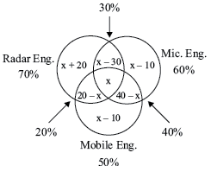

37. (c) : Minimum value '*x*' can take is 10, else less than 10 will make *x* − 10 negative.

38. (d) : Adding all values, the total would be 100%

100 = *x* + 20% + *x* − 10 + *x* − 10 + 30 − *x* + 20 − *x* + 20 − *x* + 40 − *x* + *x*

*x* = 10%

∴ Maximum it can be 10%, more than this would make the total more than 100%.

***Solutions for questions 39 to 42:***

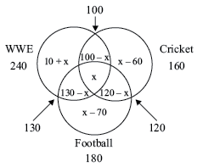

Those who watch atleast one = 10 + *x* + *x* − 60 + *x* − 70 + 100 − *x* + 130 − *x* + 120 − *x* + *x*

= *x* + 230

*x* minimum can be 60, as *x* − 60 = 0

*x* maximum can be 100, as 100 − *x* = 0.

39. (d) : (Atleast one of the given channels)minimum = 230 + 60 when *x* = 60 i.e. 290

40. (a) : Maximum atleast one of given channels = 230 + 100 when *x* = 100

= 330

41. (d) : 60

42. (a) : 100

43. (b) :

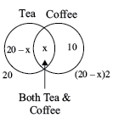

If we assume the number of persons who take only coffee as '10', then according to the given information above diagram can be drawn.

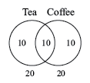

Based on the above,

(20 − *x*)2 = 10 + *x* ⇒ 40 − 2*x* = 10 + *x*

⇒ 40 − 10 = 3*x* ⇒ *x* = 10

Number of persons who take both coffee and tea (*x*) = 10

Statement (I): The sum of the number of person who take either tea or coffee or both = 10 + 10 + 10 = 30.

So, this statement is wrong.

Statement (II): The sum of the number of persons who take only coffee and those who take only tea = 10 + 10 = 20. This is twice the number of persons who take both tea and coffee (= 10).

So, this statement is correct. Hence, (b) is right answer.

44. (b) :

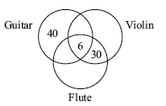

∴ Required number of musician = 120 − (40 + 6 + 30) = 44

45. (b) : Let *P*I , *P*II , *P*III represent the number of students passing in Paper I, II and III then

*n*(*P*I  *P*II) = *n*(*P*I) + *n*(*P*II) − *n*(*P*I  *P*II)

42 = 25 + 20 − *n*(*P*I  *P*II)

⇒ *n*(*P*I  *P*II) = 3

Similarly, *n*(*P*II  *P*III) = 3, *n*(*P*I  *P*III) = 3 and *n*(*P*I  *P*II  *P*III) = 1 (given)

We know that

*n*(*P*I  *P*II  *P*III) = *n*(*P*I) + *n*(*P*II) + *n*(*P*III) − *n*(*P*I  *P*II) − *n*(*P*II  *P*III) − *n*(*P*I  *P*III) + − *n*(*P*I  *P*II  *P*III)

∴ Total number of students who passed = 45

⇒ Number of students failed = 60 − 45 = 15

***Solutions for questions 46 to 49:***

The venn diagram is as follows:

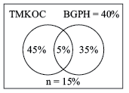

Let us say that the survey was conducted among *x* people. It is given that

 ⇒ *x* = 2000

∴ The number of people who watch only TMKOC = 900

The number of people who watch only BGPH = 700

The number of people who watch both serials = 100

46. (d) : 2000 people were surveyed.

47. (a) : 700 people watch only BGPH.

48. (b) : 900 + 700 + 300 = 1900 people watch atleast one serial.

49. (c) : 100 people watch both the serials.

50. (d) : According to the given information, the venn diagram will be as follows.

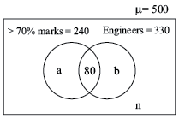

From the above venn diagram, we have *a* + 80 = 240

∴ *a* = 160

Similarly, *b* + 80 = 330

∴ *b* = 250

*a + b* + 80 + *n* = 500

∴ *n* = 10

So, *b* = 250 B.Tech. students scored less than or equal to 70% marks.

**Solution Exercise – Difficult**

***Solutions for questions 1 and 2:***

Total number of children = 85

Cost of each Ride = Re. 1

Total receipt of Park = Rs. 145

⇒ Total Rides taken = 145

We know, 20 children took all three Rides.

⇒ Cost = Rs. 60 (20 ×3)

Also, Exactly two Rides is taken by (55 − 20) *i.e*. 35 children.

⇒ Cost = Rs. 70

∴ Cost of Exactly one Ride taken = Rs. (145 − 60 − 70)

= Rs. 15

⇒ Exactly 15 children took only 1 Ride.

Now, children who did not try any ride

= 85 − (20 + 35 + 15)

= 15

1. (c)

2. (c)

3. (d) :

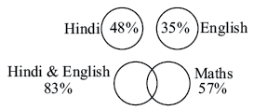

83% + 57% − *x* = 100%

*x* = 40%

∴ Maximum only 1 subject = 83 − 40 + 57 − 40 = 60%

***Solutions for questions 4 and 5:***

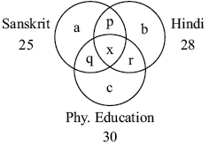

*a + b + c > x*

*a + b + c < p + q + r + x*

*a + b + c + p + q + r + x* = 50 ..... (1)

Also *a + b + c +* 2(*p + q + r*) *+* 3*x* = 25 + 28 + 30 ..... (2)

From (1) & (2),

|  |  |  |
| --- | --- | --- |
| *p + q + r* + 2*x* = 33 | | |
| Putting *x* | *p + q + r* | *a + b + c* |
| 1 | 31 | 18 |
| 2 | 29 | 19 |
| 3 | 27 | 20 |
| 4 | 25 | 21 |
| 5 | 23 | 22 |
| 6 | 21 | 23 |
| 7 | 19 | 24 |
| 8 | 17 | 25 |

*x* = 0 ⇒ *p + q + r* = 33

4. (c)

5. (b)

6. (b) :

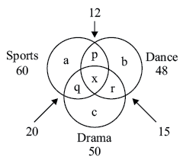

60 + 50 + 48 = *a + b + c* + 2(*p + q + r*) + 3*x*

*p + q + r* + 3*x =* 20 + 12 + 15 = 47

Minimum *a + b + c* + *p + q + r* = 158 − 47 = 111

Maximum

*x*max = 12 (Since *p* = 12 − *x*, *q* = 20 − *x*, *r* = 15 − *x*)

⇒ *p + q + r* = 11

⇒ *a + b + c* = 100

∴ *a + b + c* + *p + q + r* + *x* = 100 + 11 + 12 = 123

7. (d) :

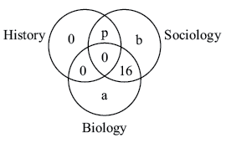

60 = *a + b* + 16 + *p*

⇒ *a + b + p* = 44

and *a + b* > 16 + *p*

Now, a minimum can be '0' & maximum can be '44'. Both these values statisfy both the equations.

***Solutions for questions 8 to 12:***

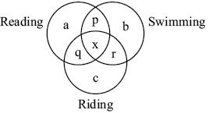

We have

*a + p + b* = 250

*b + r + c* = 400

*a + q + c* = 350

*a* = 120

*b* = 120

*c* = 120

⇒ *p* = 10

⇒ *r* = 160

⇒ *q* = 110

8. (a) : 120

9. (c) : *a + b + c + p + q + r + x*

120 × 3 + 10 + 160 + 110 + 30 = 670

10. (d) : *p + q + r* = 10 + 160 + 110 = 280

11. (a) : *p + q + r + x* = 280 + 30 = 310

12. (c) : 3 × 120 = 360

***Solutions for questions 13 to 15:***

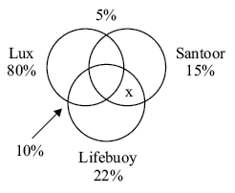

13. (b) : Since the smallest of the three is Santoor 15%, hence the maximum who can use all will be the same *i.e*. 15%.

14. (a) : Removing Lux

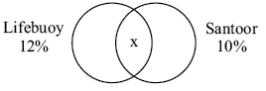

Total = 20% (Since 80% use Lux)

⇒ 12 + 10 − *x* = 20%

⇒ *x* = 2%

15. (d) : CBD

***Solutions for questions 16 to 19:***

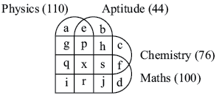

We have the following values from the question.

*q + r + i + x* = 60 | *e + p + x + r* = 10

*q + x + s + f* = 30

*g + p + q + x* = 40

*p + h + x + s* = 10

*q + x* = 10

*p + x* = 10

*r, j, x, s* = 0

⇒ *q* = 10

*p* = 10

*f* = 20

*g* = 20

*h* = 0 | *c* = 16 *d* = 20

*e* = 0 | *a* = 20 *b* = 34

16. (a) : *b* = 34

17. (a) : *g* = 20

18. (c) : Atleast two will be = *a + b + c + d + e + f + g + h + i + j + p + q + r + s + x*

Putting in the values we get this as 200.

19. (d) : Atleast 2 sections = 110 (all − (*a + b + c + d*))

None = 0

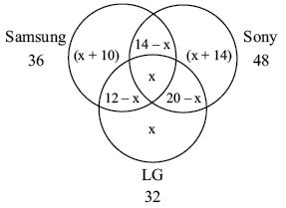

Only Samsung = 36 – [(14 – *x*) + (12 – *x*) + *x*]

Only Sony = 48 – [(14 – *x*) + (20 – *x*) + *x*]

Only LG = 32 – [(20 – *x*) + (12 – *x*) + *x*]

Hence after equating the sum total = 78

We get, *x* = 8

Now,

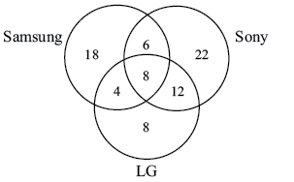

Hence ratio of people who own only Samsung to people who own only LG = 18 : 8 = 9 : 4

***Solutions for questions 20 and 22:***

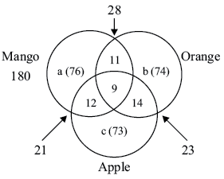

Each of Mango, Orange, Apple bottles

⇒ *a* + 32 = *b* + 34 = *c* + 35

Also, *a + b + c* + 11 + 12 + 14 + 9 = 279

⇒ *a + b + c* = 233

⇒ *a* + *a* − 2 + *a* − 3 = 233

⇒ 3*a* = 228

∴ *a* = 76

⇒ *b* = 74

⇒ *c* = 73

20. (c) : *a + b + c* = 223

21. (d) : *b + c* + 14

74 + 73 + 14 = 161

22. (a) : 11

***Solutions for questions 23 to 26:***

17 in TR

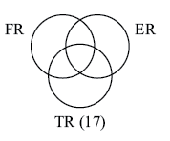

10 in TR also in at least one more ⇒ 7 in TR alone

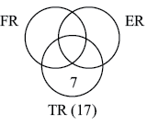

TR alone = one less than ER alone ⇒ ER alone = 8

ER alone = double of all 3 ⇒ in all three =  = 4

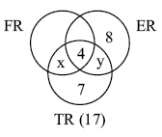

FR alone = (FR and ER)

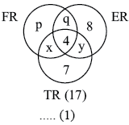

⇒ *p = q* + 4 ..... (1)

Total = 37

[7 + 8 + *p* + (*x + y + q*) + 4]

= 37 [*p + q* = 12]

⇒ *p – a* = 4 ⇒ *p* = 8 and *q* = 4

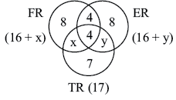

Now, total number of FR is maximum

⇒ 8 + 4 + 4 + *x* > 8 + 4 + 4 + *y*

⇒ *x > y* and *x + y* = 6



⇒ x = {4, 5, 6}

y = {0, 1, 2}

23. (c) : Both FR and TR but not ER

= *x*

Minimum *x* = 4

24. (a) : Option (b) and option (c) are superfluous. They are not required.

Option (a), if given, would tell us the value of *x* = 4 and hence *y* = 2.

25. (b) : Out of 4 who are in all three projects, 2 move out of FR and one-one move out of ER and TR.

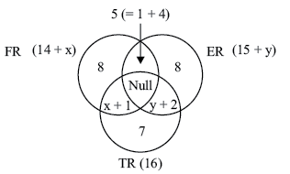

Minimum in ER = 14 + *x* = 14 + 4 = 18

Maximum in ER = 15 + *y* = 15 + 2 = 17



Hence, option (b).

26. (d) : FR and ER = 5

ER and TR = *y* + 2

⇒ 5 = *y* + 2

⇒ *y* = 3; which is not a possible value as *y* is 0, 1, or 2 only.

⇒ Option (d). Inconsistent data.